Why Spark scala?

1 to 1 with spark / dev productivity / scale / Repeated loops iteratively on same dataset until a a condition is met

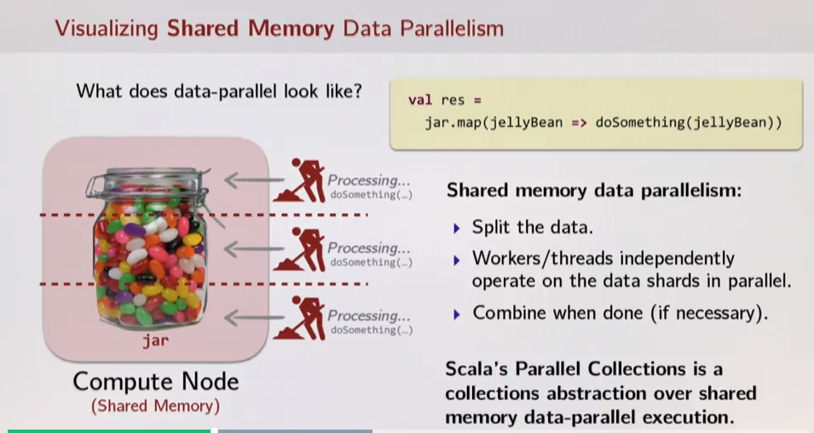

VS

Distributed:

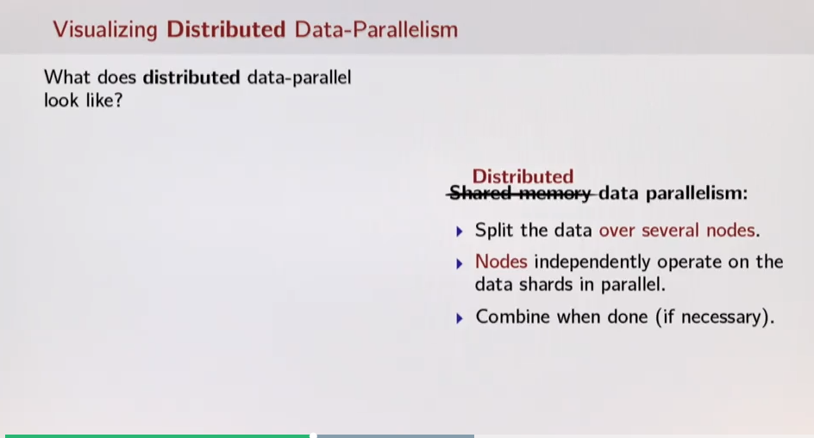

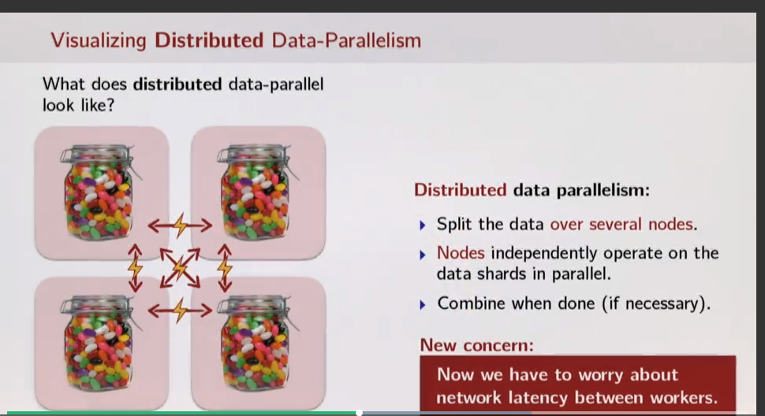

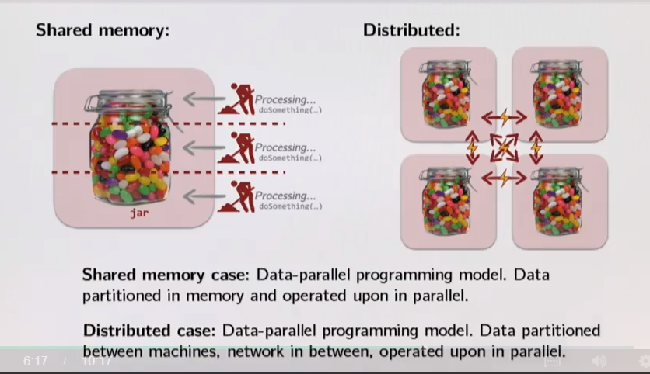

Ex: (-_-) cannot be used its not non associative

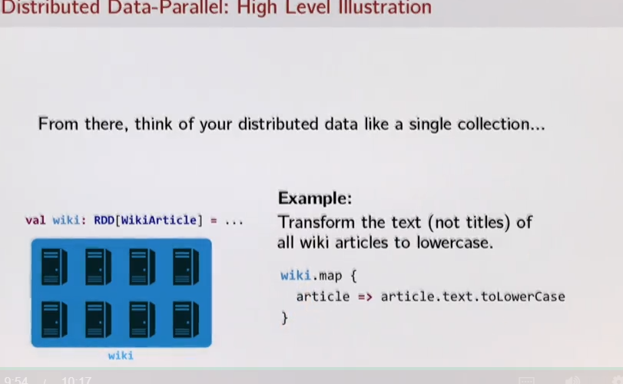

Most important concerns for Dist Computations

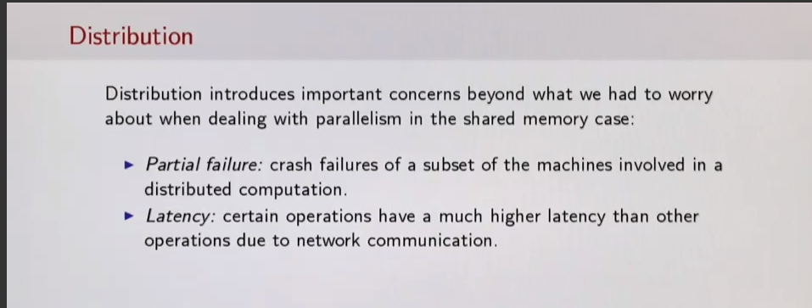

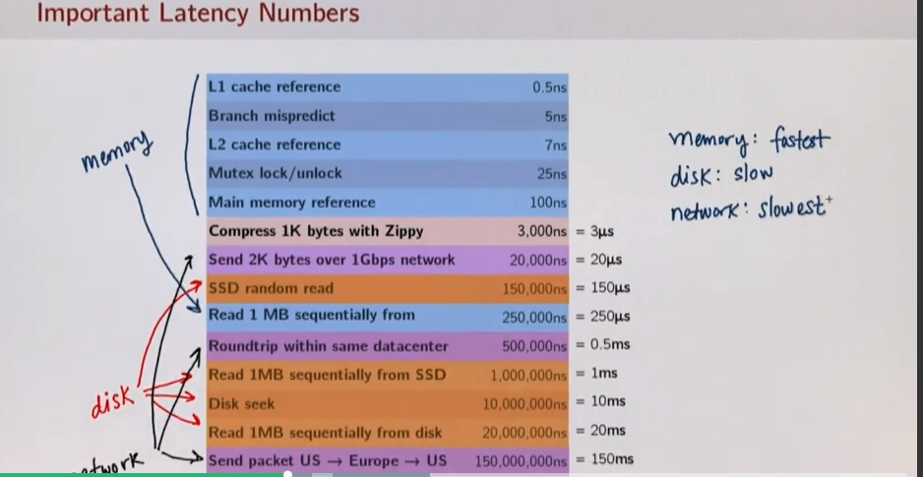

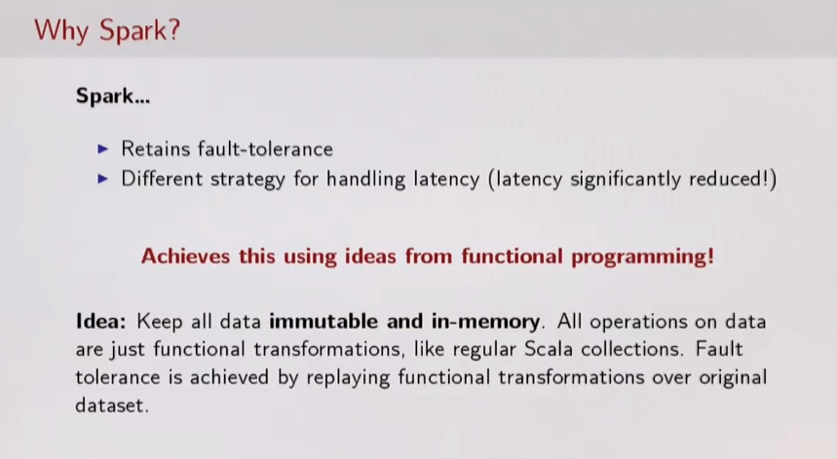

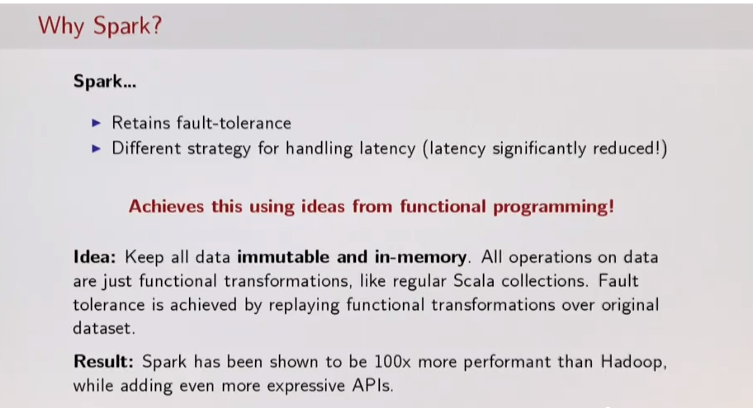

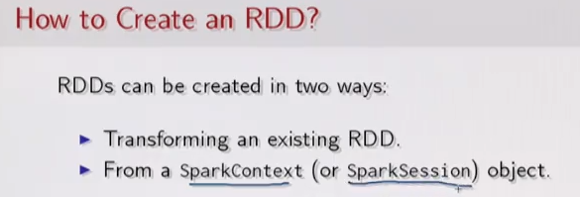

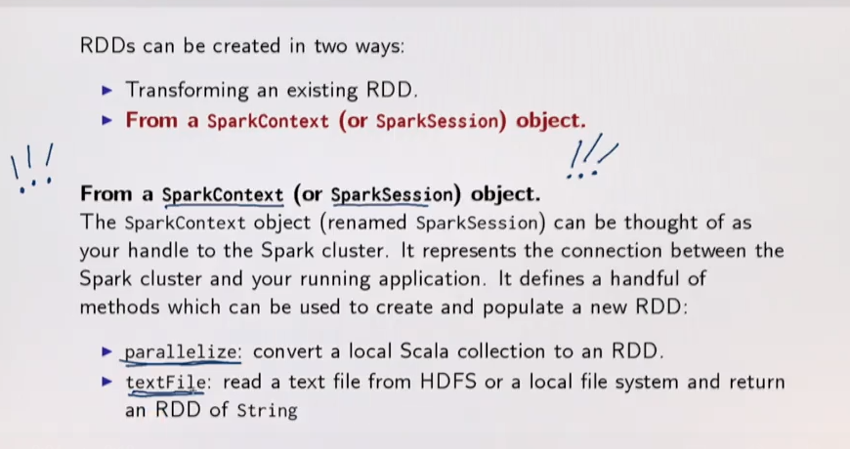

Mostly we use textFile

def textFile(path: String, minPartitions: Int = defaultMinPartitions): RDD[String]

The textFile method also takes an optional second argument for controlling the number of partitions of the file. By default, **Spark creates one partition for each block of the file (blocks being 64MB by default in HDFS),** but you can also ask for a higher number of partitions by passing a larger value

Is data broadcaste to everynode?

f you use path on the local file system (available on all nodes) and do not specify minPartitionsthe default parallelism (that depends on number of cores in your cluster) is chosen**. In this case you have to copy your file on every worker or put it into a shared storage which is available to every worker.**

In each of the cases, Spark avoid broadcasting any data and instead tries to use existing blocks in each machines. So not totally true.

According to Spark documentation:

collect(): Array[T] Return an array that contains all of the elements in this RDD

In this step your RDD b is shuffled/collected into your driver program/node.

RDDs use Higher Order Functions a lot

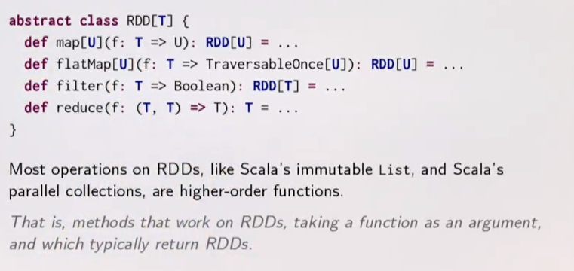

Scala returns collections([List]) while Spark returns RDDs

Transformers and ACTIONS

Transformations : are lazy

Actions: Are eager

This helps in reducing latency

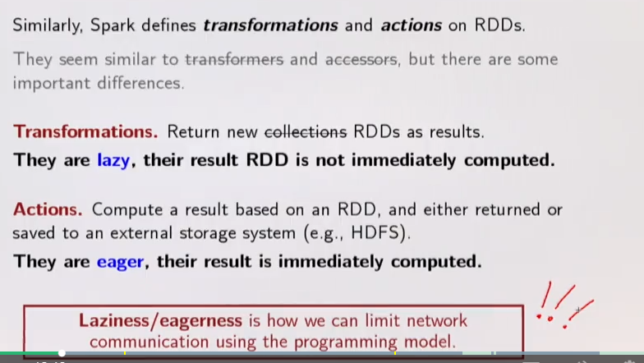

Scala to SPARK

~Use Parallelize ~

val largeList: List[String] = ...

val wordsRdd = sc.parallelize(largeList)

val lengthsRdd = wordsRdd.map(_.length) 🡨 Transformations

lengthsRdd.write 🡨- ACTION

Common Transformations [LAZY ] return RDD

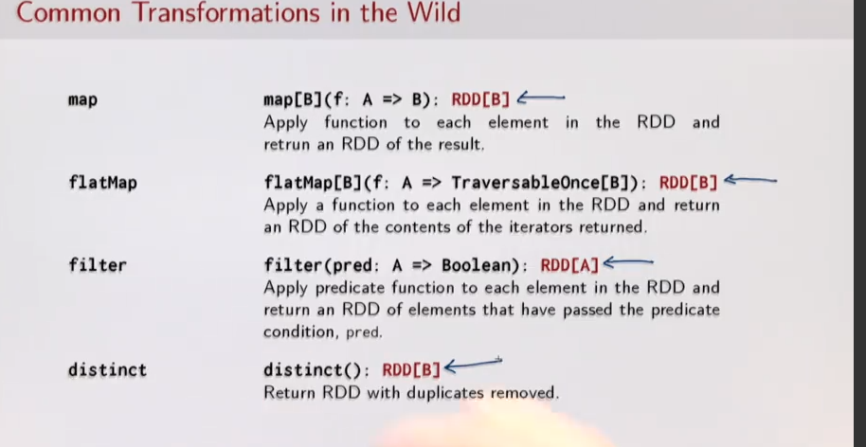

ACTIONS

~ ACTIONS ~~~~~~~~~~~~~

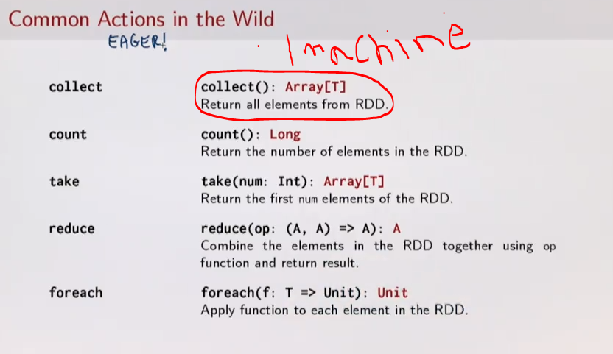

RETURN Types will give away if they are ACTIONS or Transformations

Usefulness of being Lazy

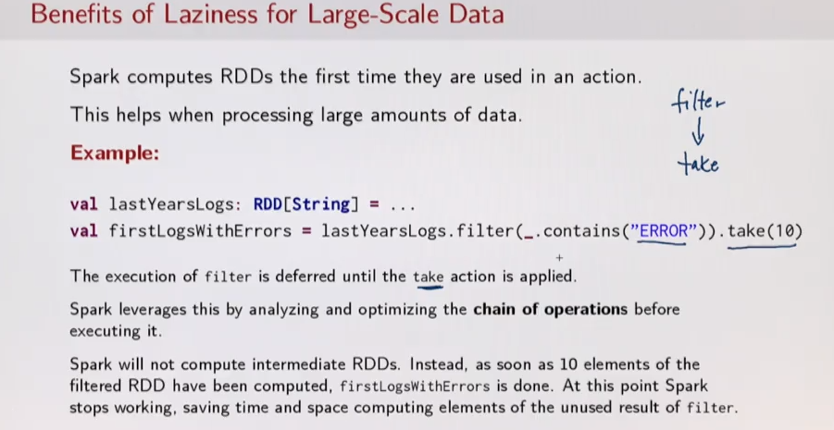

Stop computation at 10

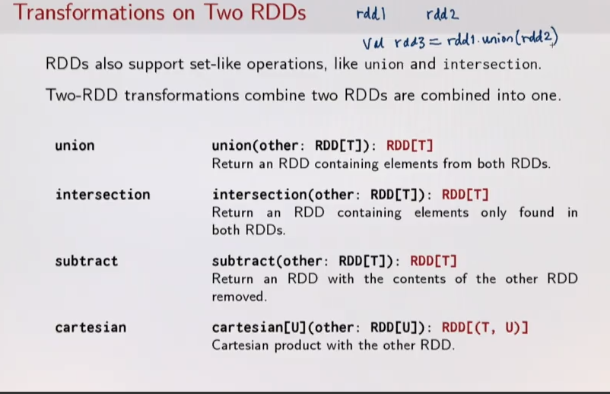

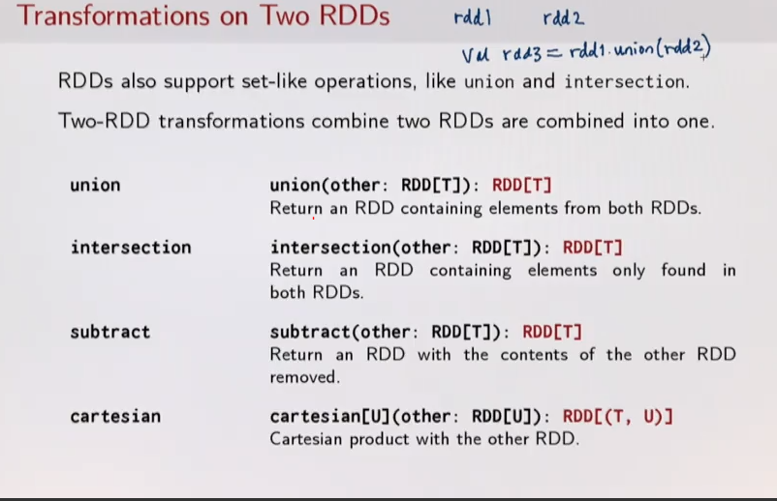

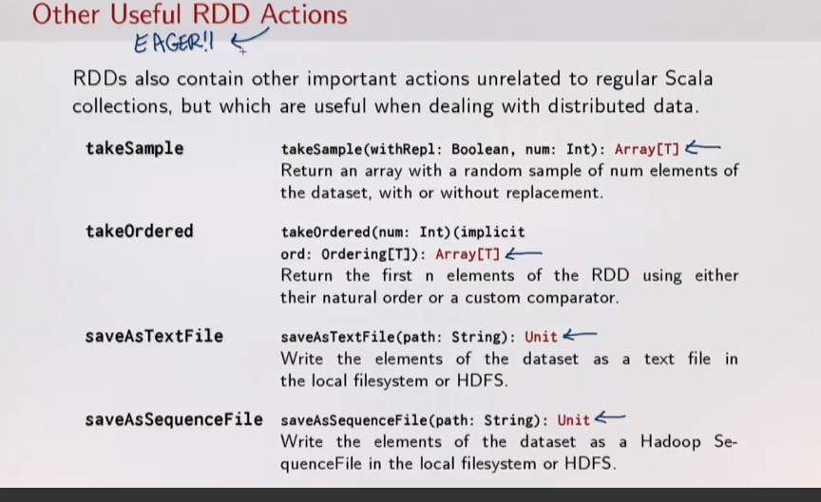

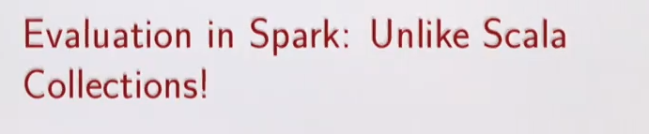

Val fhandle = sc.textFile(“ ,,,,”

Map

Reduce

Because of lazy eval The read “fhandle “ happens for every iteration …. XXXXXXXXXXXXXXXX

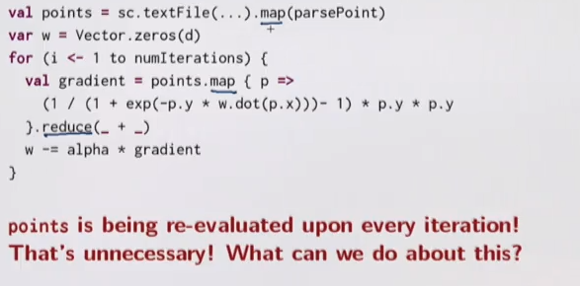

??????????????????????????????

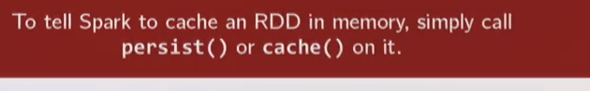

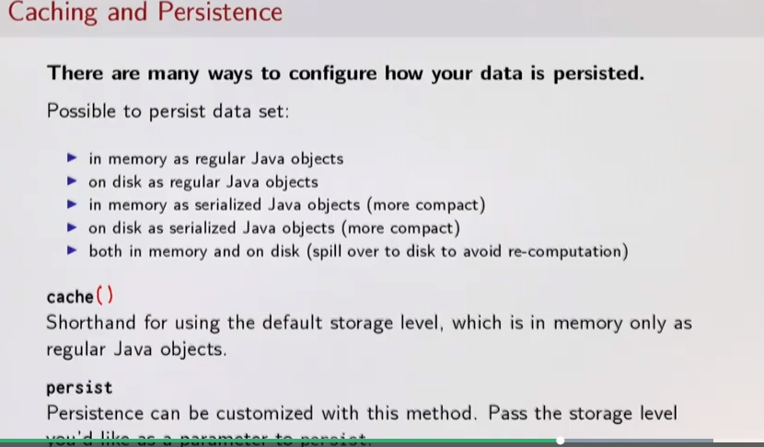

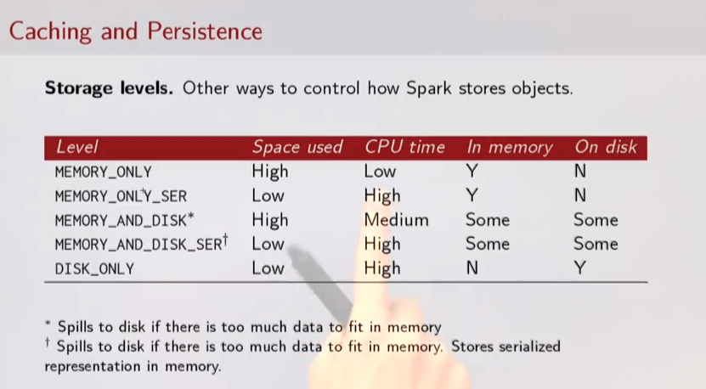

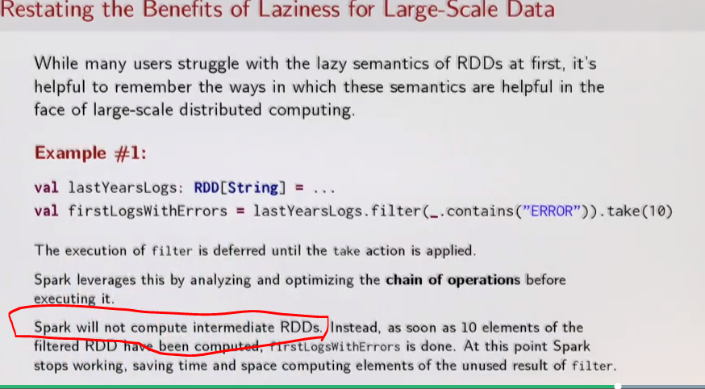

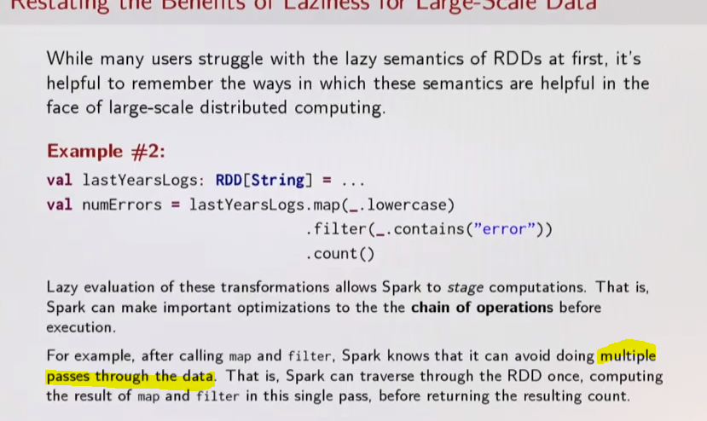

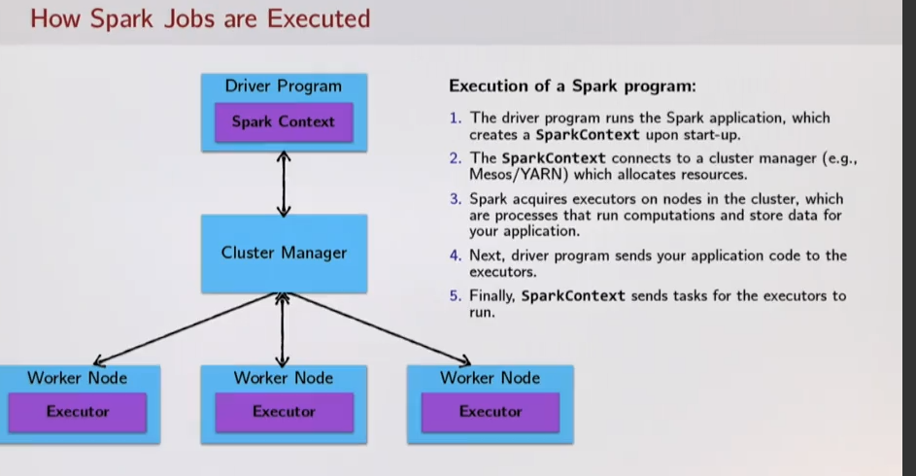

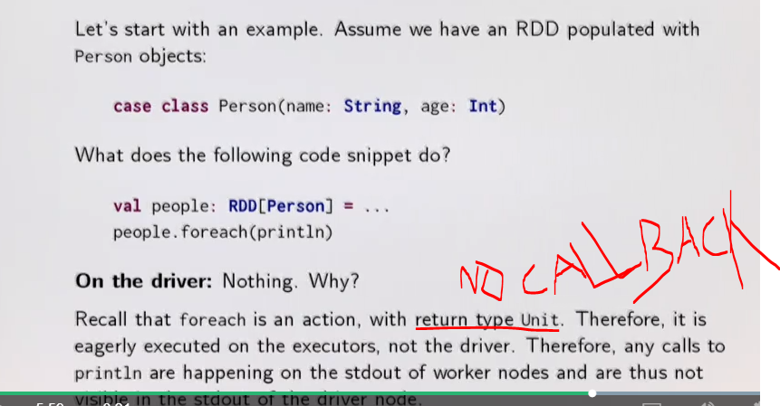

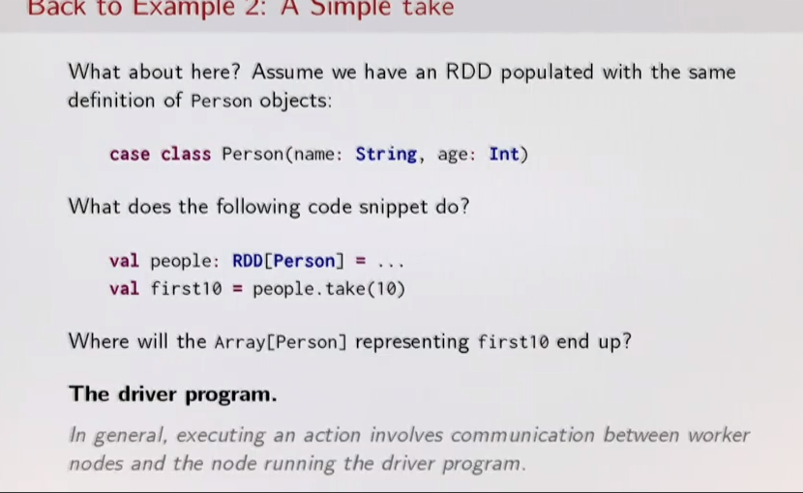

CLUSTER TOPOLOGY

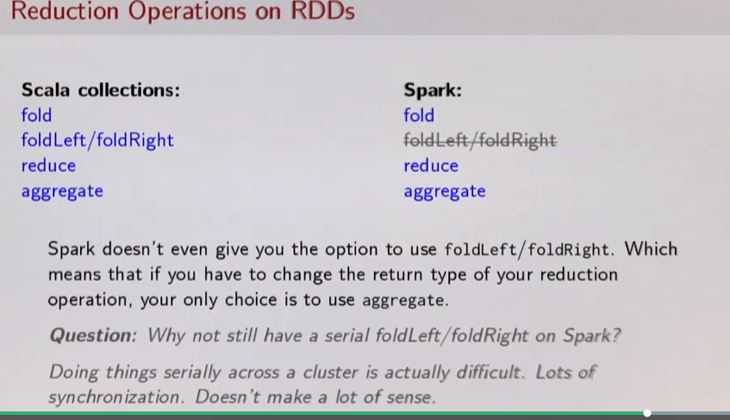

Aggregate most used as reduction nd reformat to drop baggage columns

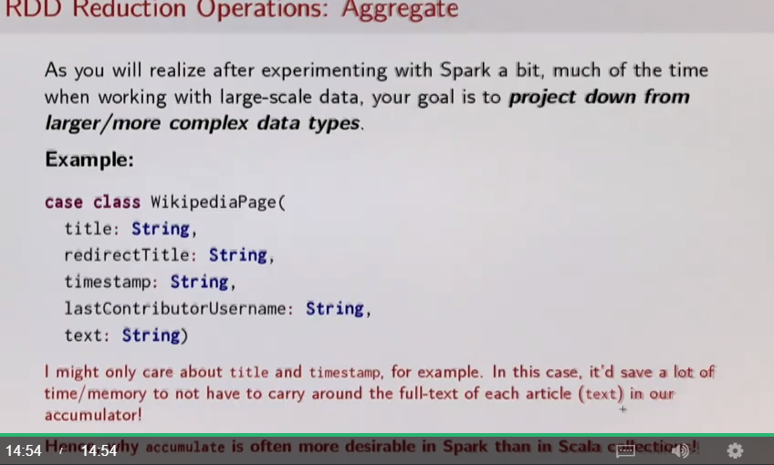

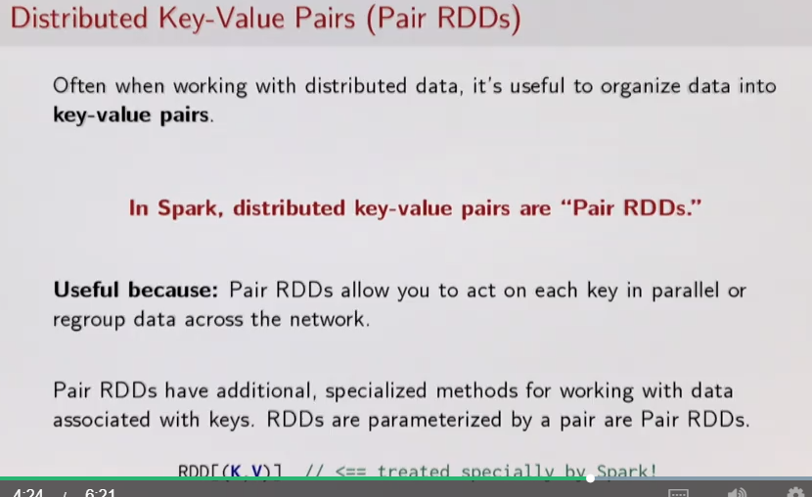

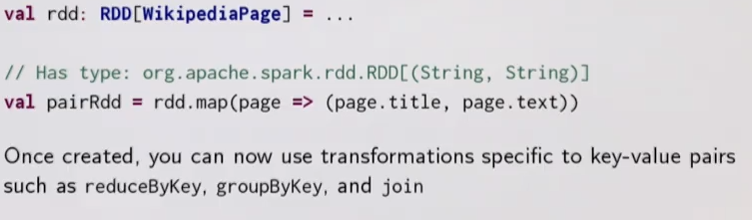

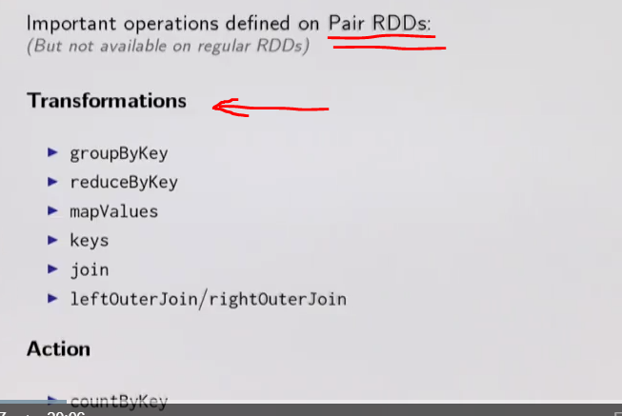

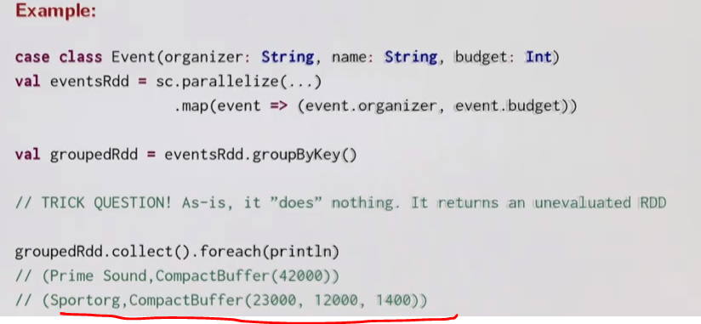

Reduce by key more efficient then roup by .

But reduce by key takes input where values are already groued by key

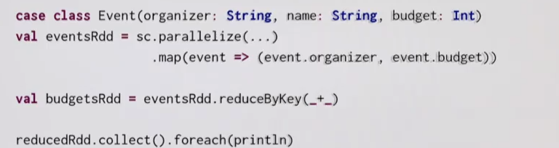

JOIN on Paired RDD

RDDx= RDD1.join(RDD2) // no concept of driving flow

RDDx= RDD1.leftOuterjoin(RDD2) // no concept of driving flow

**Partitioning and Shuffling**

* 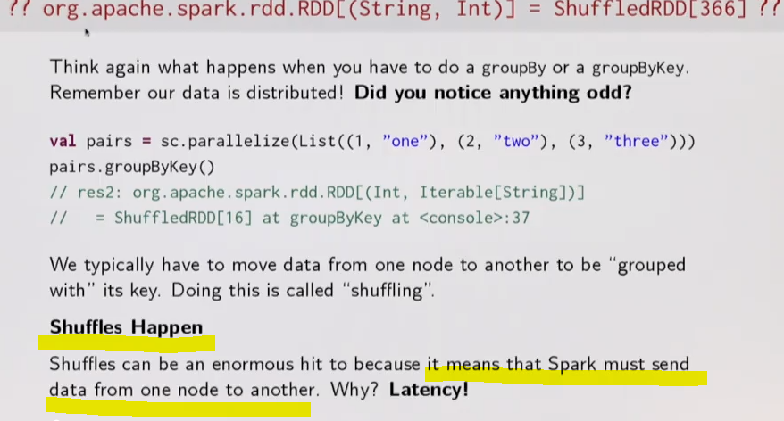

Lets solve a use case with efficient vs inefficient way



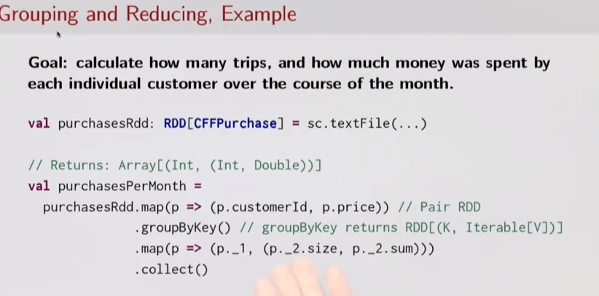

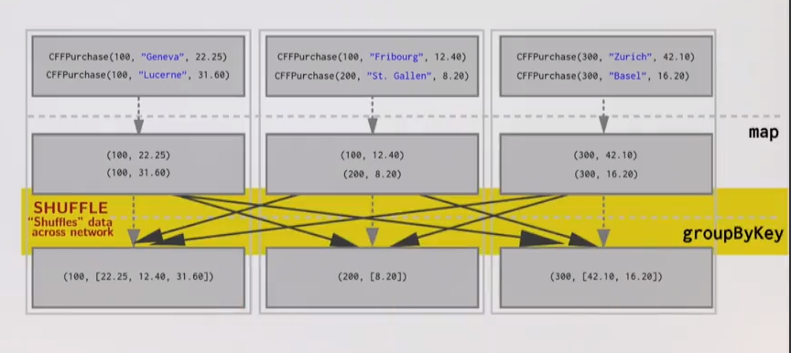

VS

REDUCE BEFORE SHUFFLE

